POSAM

Version 1.2 - November 2023

Movement IN / OUT check for extraction

On Item/Movement, you can now ask for IN and OUT of the inventory, or only IN, only OUT.

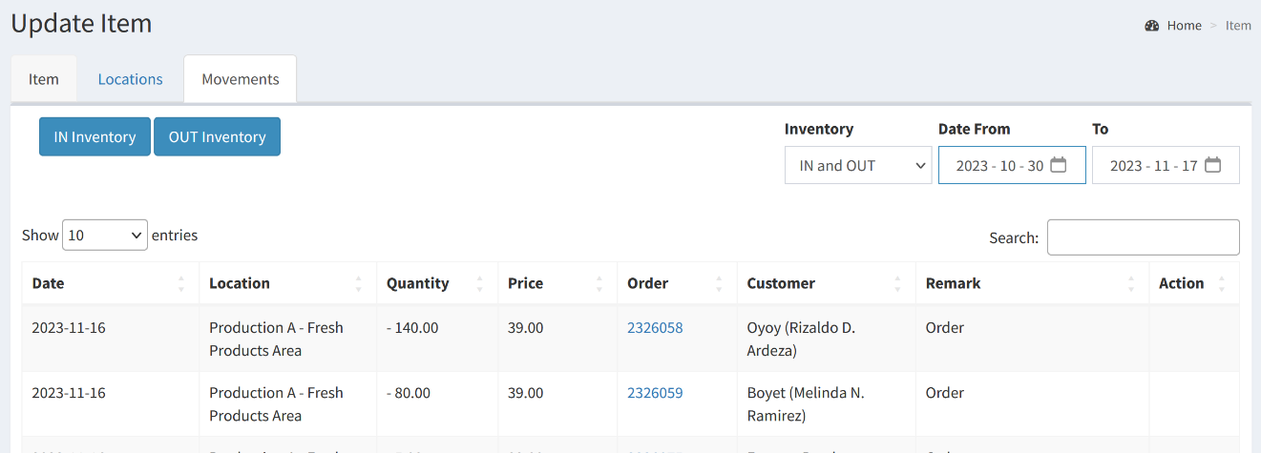

DATE

Concerning the problem with the date on the server. The date is now settled with Manila time.

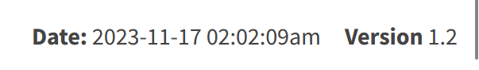

ITEM and decimal

The process of decimal for the quantity is working in the ITEM/movement screen. It was available while ordering but not in the movement of the ITEM.

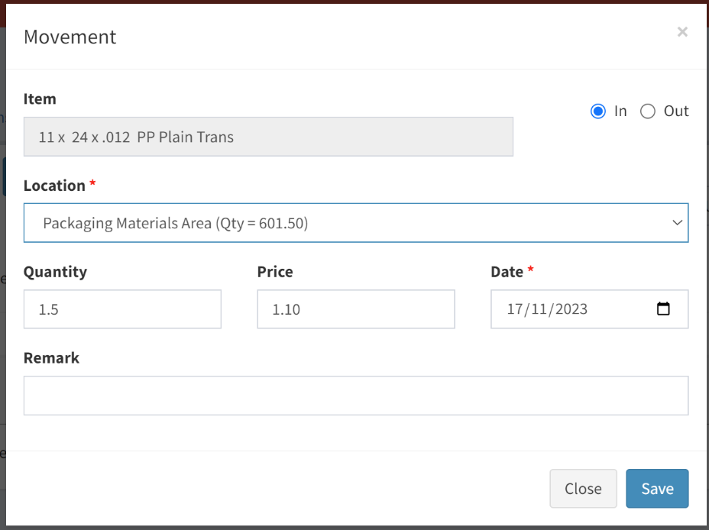

PRICE

It is now possible to change the price for the item when you are in the movement tab of the ITEM. The normal price will appear automatically but you will be able to change the price for this transaction (IN or OUT). It won’t change the normal price in the ITEM screen.

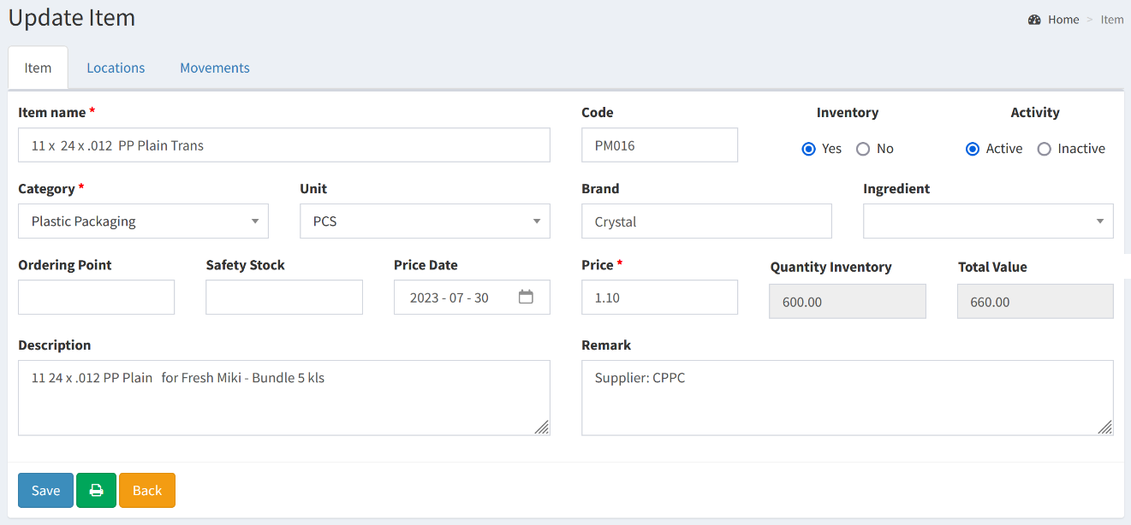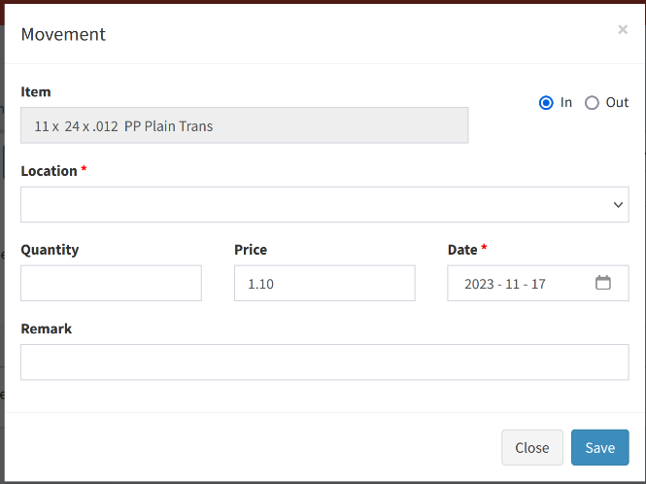

Production LEVEL

Has been changed for Ordering Point. Another field Safety Stock is available.

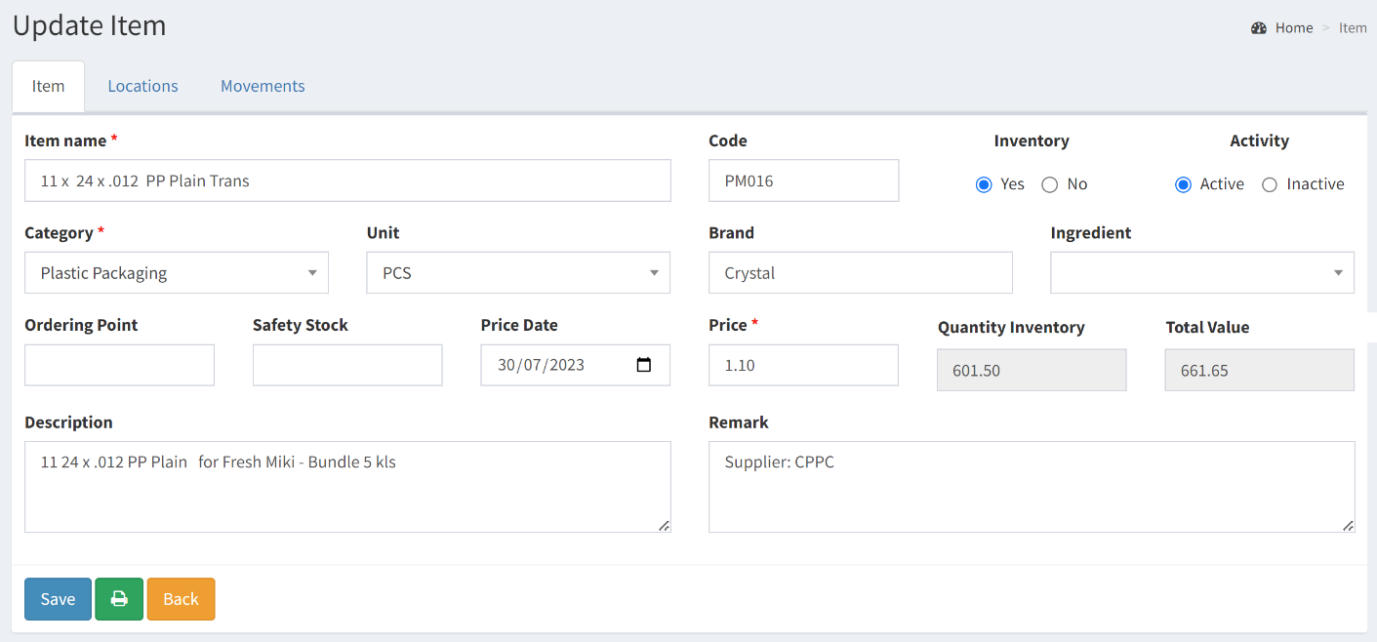

For now, you will be able to extract using Report 01 in List format. You will see the Ordering Point and Safety Stock. I will need more details on how you will use these 2 fields. I didn’t fully understand how you will work with the percentage that would allow me to give the list of items you need to order….

